**JETSHD**

**Version 0x1.3**

**Overall Description:**

This product provides users the ability to implement multiple functions (such as GPIO and UART) that need to interact with J3A2 Connector, also as known as the Expansion Headers, on the NVIDIA JetsonTK1 board.

**Features:**

* Dimension: 70mm*23.5mm
* Build with 2mm pitch dual row male header pins which allows the user to directly plug onto the Expansion Headers
* Build-in 6 channel Level shifters (Low voltage 1.8v, High voltage 5v)
* Connector J4: JST 2.54mm 2-Pin Connector provides GPIO (2 and 3) debugging capabilities
* Connector J3: JST 2.54mm 2-Pin Connector provides UART communication (UART 1) with a build-in RS232 circuit
* Connector J2: JST 2.54mm 2-Pin Connector provides UART communication (UART 1) with build-in RS485 circuit
* Connector J1: 4-Pin RJ11 connector provides a level-shifted Rx and Tx (UART 0 with voltage level: 5v) that can be connected to Arduino or so

**Note:**

* UART 1 from JetsonTk1 board are shared between RS232 and RS485
* UART 0 from JetsonTk1 board works alone with Connector RJ11 after voltage converted
* Any other function besides UART and GPIO has not been developed with this Version of JETSHD
* *The Front Panel Headers will be covered when using this JETSHD.

**Connectors Pin Configuration Diagram**

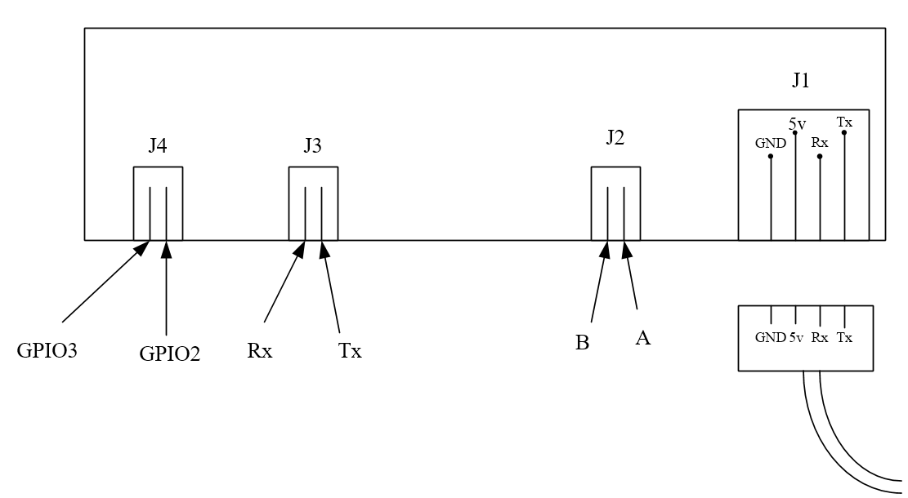

**References:**

About Level Shifter: <https://learn.sparkfun.com/tutorials/bi-directional-logic-level-converter-hookup-guide>

About RS485: <http://cds.linear.com/docs/en/datasheet/485fm.pdf>

About JetsonTK1 Module Spec: <http://developer.download.nvidia.com/embedded/jetson/TK1/docs/3_HWDesignDev/JTK1_DevKit_Specification.pdf>